EXPERIMENT- 01
Convert an Image to Grayscale
Aim
To write a Python code to read a color image and convert the image into grayscale format using OpenCV for basic image processing applications.
Input Image
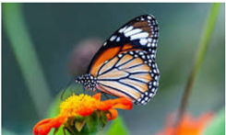
Code
import cv2
from google.colab.patches import cv2_imshow
from google.colab import files
uploaded=files.upload()
image_path=list(uploaded.keys())[0]
image=cv2.imread(image_path)
if image is None:
print("Error: Image not found")
else:
gray_image=cv2.cvtColor(image,cv2.COLOR_BGR2GRAY)
print("Original Image")
cv2_imshow(image)
print("Grayscale Image")
cv2_imshow(gray_image)
Output Image
Grayscale Image
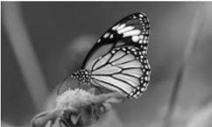
Result
Thus, the image was successfully converted into grayscale using OpenCV.

